**Quote to Live By:**

 Students will choose a favorite quote that is meaningful to them. They will copy the quote onto an index card and decorate it. They will then share their quotes with the class. Hang on board in hall way

**Personal Coat of Arms:**

Students will decorate their own coat of arms using the template below

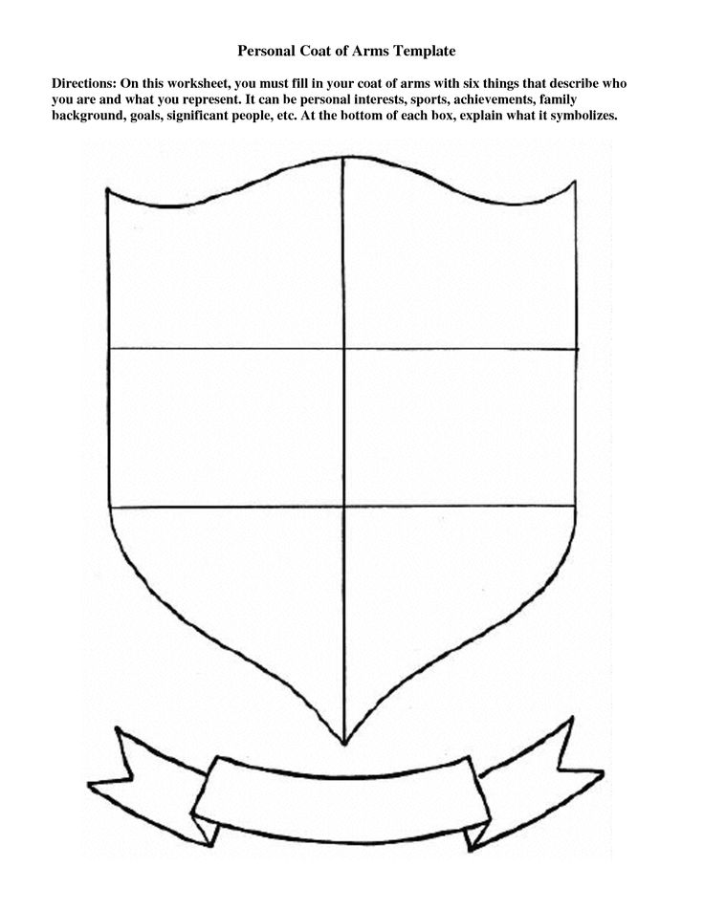

**Ah, Um Game:**

Summary: Kick the “ah, um” habit and avoid these words in natural conversation.

Goal: Avoid saying the taboo words “Ah”, “Um”, “Like”, or “You Know”.

Preparation:

- List of topic ideas

- Timer/watch

How to Play The Ah, Um Game:

**1.** Separate everyone into groups of about three or four. A person must talk to their group about a certain topic for one full minute without saying the following taboo words: “Ah”, “Um”, “Like”, or “You Know”. If the person does not say the taboo words in the round, then the person can move to the second round. If they accidentally say a taboo word, then it'll be the next person's turn.

**2.**Have one person in each group volunteer to be first. Use the timer/watch to track a minute and announce one of the topics listed below.

**3.** Afterwards, have a different person from each team volunteer to go next and repeat the same exercise as above. The people who avoid saying the taboo words are the winners of the game.

List of Topic Ideas:

-Favorite Movie

-Favorite Animal

-Best Gift

-Favorite TV Show

-What did you do last week?

-Summer Activities

-Birthday Party

-What would you do with $10,000?

-What do you want to be when you grow up?

-What is your favorite activity?

-What is your favorite dessert?

**Build Your Dream Community:**

Students will get into groups of two to three students. They will create a map of their dream community. They will design a map and put any buildings they want on the map. They will have to share their community with the class and explain why they picked the buildings that they did.

**What does this school need:**

Students sit in groups and think about a problem they have with the school. They will then come up with a plausible solution for the problem. They will share their solution with the rest of the class and the class will vote on the problem and solution they most want to fix. The next TAG class students will start to put the plan in action.

**Toilet Paper Costume:**

Students will divide into groups and each group will be given a roll of toilet paper and tape. They will have 15 minutes to design a toilet paper costume. At the end of the 15 minutes each group will show the class their costume.

**Valentines for Veterans:**

Students will create Valentines Day cards for men and women serving in the armed forces. Students can make a card for a service person they know personally or the cards will be sent to an army base.

**Two Truths and a Lie:**

Summary: Which sentence is a lie? A fun guessing game, great way for people to get to know one another.

Goal: Correctly guess other people’s truths and fool other people into guessing your lie.

Preparation:

- You will need to pass out a pen/pencil and paper to each person participating.

How to Play the Two Truths and a Lie Game:

**1.** Have everyone write two true sentences and one false sentence on their papers. The sentences can be in any order that they want. Make sure that all the sentences are believable, and aren’t obvious. (Example Statements: I have three cats at home; I am related to a celebrity; I had lost two teeth in a biking accident).

**2.** Each person will need to read their sentences aloud to the group. After reading each sentence, everyone will need to think about which statements are truths are which sentence is a lie.

**3.** Take a vote on which statement is a lie (“Who thinks the first sentence is a lie? Who thinks the second sentence is a lie?”).

**4.** The players who chose the lie correctly will win one point. The person who wrote the sentences will win two points for every person that they fool (for every person who voted the truth statement was a lie).

**5.** Go around and follow steps 2-4 for the remaining players. Whoever gets the most points wins the game.

**Character Ed Days:**

Character Ed days are days when students learn about different character education traits. Examples are respect, honesty, knowing yourself, and responsibility. Students watch movie clips that relate to the character trait of that day and then answer discussion questions.

**Outside Games:**

When the weather is nice sometimes students will get to go outside and play games. Some examples of games are:

Four Square

Silent Ball

Heads Up Seven Up

Werewolf

Wall Ball

**Tower Building**

Students are given one pack of notecards and they are instructed to build the highest tower that they can within the ten-minute time limit. Students can only use the pack of notecards and must work together as a team.